Checking Version of Excel:

Three methods of finding the version of Excel on your PC.

1. Search for excel.exe – open file location

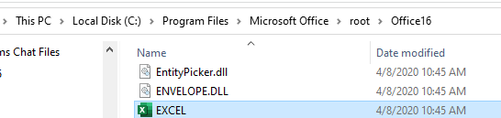

Right mouse click, choose properties. This is version of excel, and last date updated.

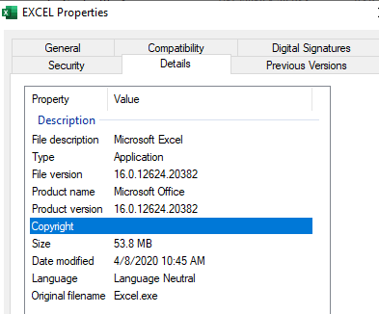

2. Open blank Excel document:

File, Account

This is Paige’s PC screenshot below:

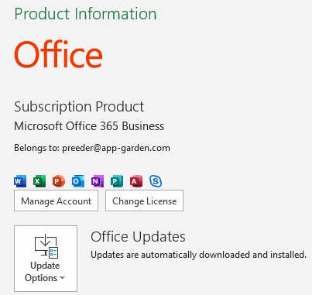



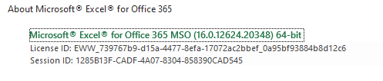

The above screen is not necessarily accurate.

Control panel and first method are.

3. Control Panel

